Create a function that takes the following three input agreements

1. actual: list of actual values (y)
2. predicted: list of predicted values (y hat)
3. sample_weights: list of weights that each pinball loss should be scaled by
4. quantile: which quantile the pinball loss should be calculated for

And calculates the weighted average pinball loss. As a recap, pinball loss is defined as:

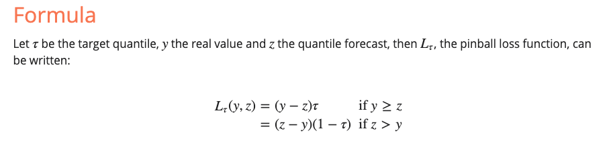

Each loss should be multiplied by it's sample_weight and divided by the sum of the sample_weights.

Round your solution to the third decimal point. eg: 2.2627499999999996 => 2.263

****[execution time limit] 4 seconds (py3)****

****[input] array.float actual****

y

****[input] array.float predicted****

y hat

****[input] array.float sample_weights****

used to calculate the weighted average

****[input] float quantile****

between 0.0 and 1.0

****[output] float****

Average pinball lost

****[Python 3] Syntax Tips****

**# Prints help message to the console# Returns a stringdef helloWorld(name):**

**print("This prints to the console when you Run Tests")**

**return "Hello, " + name**

def solution(actual, predicted, sample_weights, quantile):